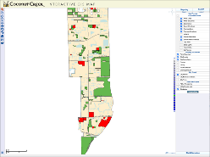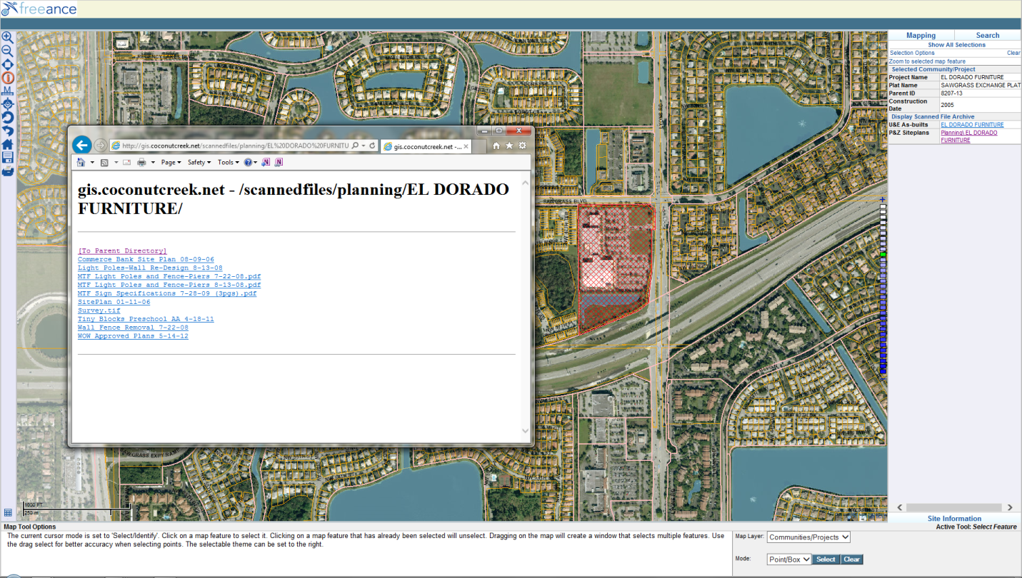

**STEP 1:** Choose the Identify tool while the map redraws

Access the City’s **GIS on the Web** interactive mapping application (shown below) by going to **http:coconutcreek.net** 🡪 Government 🡪 City Maps 🡪 GIS on the Web🡪

Then, zoom-in to the area of interest and follow the 5 steps shown below:

**STEP 5:** Display the images of available plans, or the contents of project subdirectories, by clicking on the links

**STEP 4:** Display the directory of scanned files by clicking on the link for your chosen project. Both Utilities & Engineering as-builts and Planning & Zoning site plans are available for online viewing

**STEP 3:** Choose the Community or project of interest

**STEP 2:** Set the selection layer to: Communities/Projects