City of Coconut Creek

Development review committee (DRC) REVIEW #***3***

***5-7-14***

|  |  |  |  |  |
| --- | --- | --- | --- | --- |
| **PROJECT NAME:** | | Fire Station | | |
| **PROJECT NUMBER:** | | PZ-14020004 | | |
| **LOCATION:** | | 1100 Lyons Road | | |
| **APPLICANT/AGENT:** | | Scott Stoudenmire | | |
| **REVIEW/APPLICATION** | | Site | | |
| discipline | REVIEWEr | | EMAIL | Telephone |
| DRC Chair, Zoning | Heidi Solano – Senior Planner | | [hsolano@coconutcreek.net](mailto:hsolano@coconutcreek.net) | (954) 973-6739 |
| Building | Sean Flanagan - Chief Structural Inspector | | [sflanagan@coconutcreek.net](mailto:sflanagan@coconutcreek.net) | (954) 973-6750 |
| Engineering | Albert Demarcado - Engineer II | | [ademercado@coconutcreek.net](mailto:ademercado@coconutcreek.net) | (954) 973-6786 |
| Fire | Rodney Zancanata - Deputy Fire Marshall | | [rzancanata@coconutcreek.net](mailto:rzancanata@coconutcreek.net) | (954) 973-1563 |
| Green Review | Jim Hetzel - Sustainable City Coordinator | | [jhetzel@coconutcreek.net](mailto:jhetzel@coconutcreek.net) | (954) 973-6756 |
| Landscape | Scott Peavler - Landscape (consultant) | | [speavler@coconutcreek.net](mailto:speavler@coconutcreek.net) | (954) 973-6756 |
| Police | Henry Cabrera - Police Department | | [hcabrera@coconutcreek.net](mailto:hcabrera@coconutcreek.net) | (954) 956-6721 |

## **DEPARTMENTAL COMMENTS**

|  |
| --- |
| **ENGINEERING** |

**General Engineering Conditions of Approval:**

1. Provide complete storm drainage calculation.
2. Provide bench mark designation (elevation on PRM or other permanent survey station). Frame and grate or rim elevations are not acceptable. Need to clearly show PRM and its elevation on design plan or survey.
3. Clearly show all type of pipe, invert elevations, pipe sizes, etc., on larger size drainage. Some structures have multiple inverts but only show one invert. Applicant need to clarify by showing directions (E, W, N or S) adjacent these inverts for additional clarification on the plans. Drainage pipe between manholes S-4 to Ex-3 need to show length, type and size of pipe.
4. Clearly identify setbacks of building from existing utilities.
5. The driveways indicate no access, this restriction shall be removed. Provide correspondence from Broward County confirming that the no access restriction has been removed.
6. No permanent structure shall be constructed over existing/proposed easements.
7. Show radius of all proposed curbs and pavement, which shall comply with City standards. Minimum radii at street intersection shall be 25 feet. Southern egress/ingress show 24 feet radius on sheet C-2 which shall be corrected.

|  |
| --- |
| **GREEN** |

**City Green Plan**

1. Sheet SP-3L: Revise the sign detail to reflect the information below.
   1. **Action 6.4:** Implement an alternative vehicle parking program to designated parking areas for alternative vehicles in developments throughout the City by 2020.

The City is encouraging the designation of alternative fueled parking space(s) for all projects in the City including any electric charging spaces. Indicate if this project will contain such as space. The City has adopted new alternative fuel parking sign standards and plans must contain this detail and be noted accordingly.

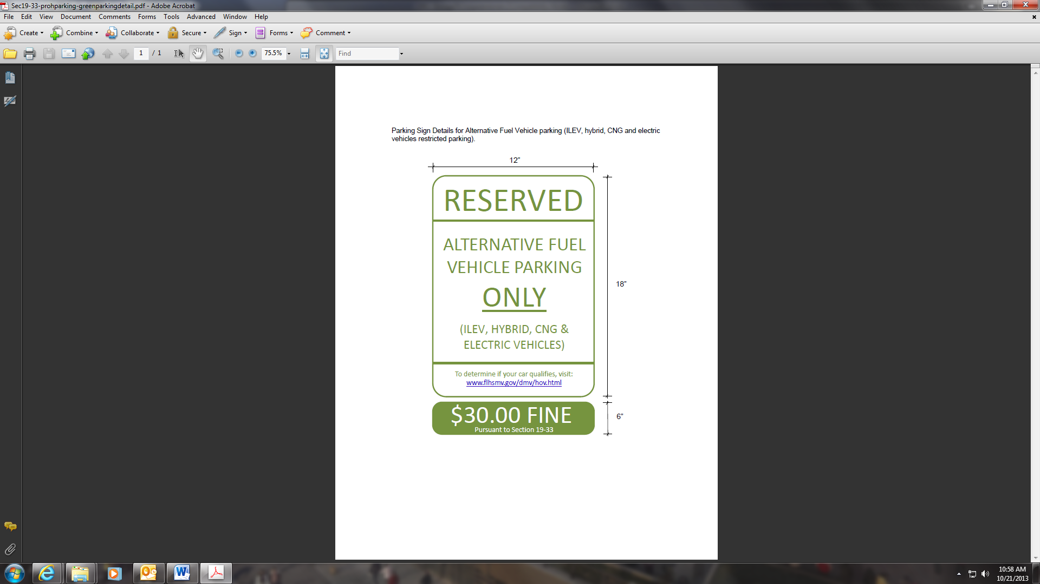

|  |
| --- |
| **LANDSCAPE ARCHITECTURE** |

**General:**

1. Provide proposed shrub counts on data table. Tables show zero provided for shrub totals.
2. On the data table under Sec. 13-443 (15) (a), add the word “width” to the section heading and feet or an apostrophe to the numbers. Will help clarify that these are dimensions, not plant counts.
3. Sabal Palm TR2253 conflicts with and existing yard drain. Shift palm location so there are not issues.

|  |
| --- |
| **PLANNING AND ZONING** |

**Conditions of Approval**

1. Non-vehicular Access Line: Modification of the non-vehicular access line along the eastern property line may be required prior to building permit.

2. Undergrounding of Utilities: Overhead utilities adjacent to the site, along Coconut Creek Parkway, to be addressed at the time of streetscape improvements.